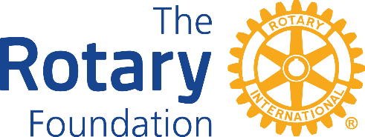

The Rotary Foundation (TRF) District 1210

DISTRICT GRANT REPORT FORM 2023-24

2014-5

The Rotary Club of

Title of Project -
Names of Supporting Club

Project Final Report: (if the answer to any of the following questions is no please supply a full explanation)
Was the project successfully completed? Date:
Was the project as described in the application?
For an interim report state the proposed date of completion of the project?
If this is an interim report DO NOT complete the Final Report or Financial Statement Questions
Are all invoices/receipts held by the club?
Is an income/expenditure account attached?
Project Financial Statement:
What was the final exact total value of the project?
What was the exact total amount of Grant you received?
Is the amount of grant received more than 50% of the final total value of the project?
If YES any underspent grant must be paid back to District 1210 Foundation
DO NOT send any payment until you are advised to do so

PLEASE NOTE:
The deadline for submitting INTERIM REPORTS is Sunday 31st March 2024
The deadline for submitting ALL FINAL REPORTS is Friday 31st May 2024
PLEASE email all reports to Barry Lewis lewis7463@aol.com
Copy to Geoff Ward geoffreybward1@gmail.com

Name of Lead Rotarian:
Email address of Lead Rotarian:
Telephone contact for Lead Rotarian: Home: Mobile:
Date of Report:
Is this an Interim Report?
Were all the funds allocated to the project spent on the project?

