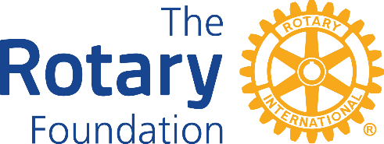

The Rotary Foundation (TRF) District 1210

DISTRICT GRANT REPORT FORM 2022-23 20222222242424

2014-5

Project Financial Statement:
Is an income/expenditure account attached?
Are all invoices/receipts held by the club?
Was the project successfully completed? Date:
Was the project as described in the application?
Project Final Report: (if the answer to any of the following questions is no please supply a full explanation)
If this is an interim report DO NOT complete the Final Report or Financial Statement Questions
For an interim report state the proposed date of completion of the project?

Names of Supporting Club

Is the amount of grant received more than 50% of the final total value of the project?
If YES any underspent grant must be paid back to District 1210 Foundation
DO NOT send any payment until you are advised to do so

Title of Project -
The Rotary Club of

What was the final exact total value of the project?
What was the exact total amount of Grant you received?

PLEASE NOTE:
The deadline for submitting INTERIM REPORTS is Friday 31st March 2023
The deadline for submitting ALL FINAL REPORTS is Wednesday 31st May 2023
PLEASE email all reports to Barry Lewis lewis7463@aol.com
Copy to Geoff Ward geoffreybward1@gmail.com

Were all the funds allocated to the project spent on the project?
Is this an Interim Report?
Date of Report:
Email address of Lead Rotarian:
Telephone contact for Lead Rotarian: Home: Mobile:
Name of Lead Rotarian:

