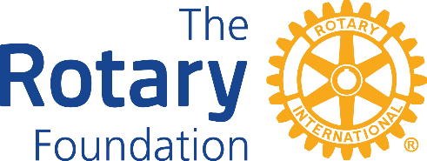

The Rotary Foundation (TRF) District 1210

DISTRICT GRANT REPORT FORM

2021-22

2014-5

For an interim report state the proposed date of completion of the project?

PLEASE NOTE:
The deadline for submitting INTERIM & FINAL REPORTS (where possible) is 31st MARCH 2022. The deadline for submitting ALL FINAL REPORTS is 31st MAY 2022.
The Rotary Club of

Title of Project –
Names of Supporting Club

Lead Club
Email address of Lead Rotarian:
Date of Report:

Project Final Report: (if the answer to any of the following questions is no please supply a full explanation)
Was the project successfully completed?
Was the project as described in the application?
If this is an interim report DO NOT complete the Final Report or Financial Statement Questions
Is an income/expenditure account attached?
Project Financial Statement:
What was the final exact total value of the project?
What was the exact total amount of Grant you received?
Is the amount of grant received more than 50% of the final total value of the project?
If YES any underspent grant must be paid back to District 1210 Foundation
DO NOT send any payment until you are advised to do so

PLEASE email all reports to lewis7463@aol.com & janecooper2612@gmail.com
Name of Lead Rotarian:
Is this an Interim Report?
Telephone contact for Lead Rotarian: Home: Mobile:
Were all the funds allocated to the project spent on the project?

