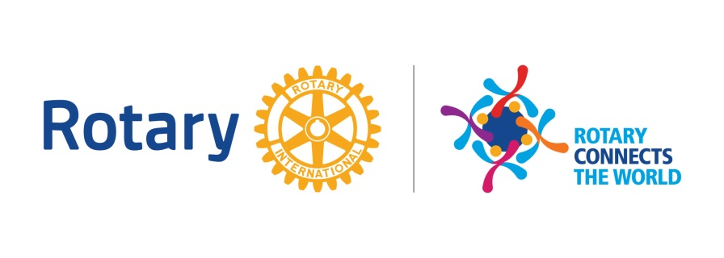
District Governors Notes for February 2020
The Rotary Year has continued with much variety, opportunity and challenge. I hope you all were safe during the floods and adverse weather we have all experienced. The world continues to be affected by much disease, strife and natural disasters. Coronavirus has become centre stage as the progress of the disease and its containment becomes a central focus for us all. Current advise is most important to prevent and protect everyone. We are not being advised to stop meetings or events at present but the situation does need constant monitoring and effective control.
Relief and support for many via our grants and projects is vital. The local floodings in Shropshire and particularly Ironbridge have called upon our clubs to support appeals from Rotarygbi Disaster Aid fund and the Ironbridge Rotary appeals. The situation in Australia has hugely improved and fires are now all out in New South Wales so giving to the Rotary appeal https://rawcs.org.au/disasters/ is supporting rebuilding community projects and aid donations can also be sent to the Rotarygbi Disater Aid Fund via Alcester.
The Health Awareness Day planning for local club events continues in March following another first for our district with the training and approval by the “Stoke Association” of 16 non medical Rotarians to take and record Blood Pressures at our local club events as part of the Health Awareness Days we run. All clubs are invited to Support/attend the planning meetings on March 18th Walsall Academy 4pm or 10th March, Tern Hill 10am.
February saw the announcement of our Vocational Study Exchange Team Leader Dr Mukunda (Walsall Rotary) and the selection of Team members to go to Denmark in September. We shall be welcoming the Finnish Team to District 1210 in April 2020 and support from clubs at arranged club events would still be appreciated. Details of the programme are available from the district lead, contact G Dean graham@gandjdean.com .
February saw the completion of many of the local District 2020 Youth Competition finals; Young Chef, Young Musician, Youth Speaks, with Writer, Photographer and others to conclude this month, all the details are on the district website if you need further information: Regional Young Musician and Youth Speaks at Wrekin college this Sunday.
Please note National Finals for some of these are planned to happen at the Rotarygbi EXPO taking place at the NEC 1-3rd May 2020. Make a note of the date and plan to see Rotary in action with many partners and project facilitators at this local venue. Visit https://www.youtube.com/watch?v=JUPZyT_5g-U to see whats on and why you should go.
Congratulations to Dr Viquar Qurashi (Sedgley) for being Nominated as a Rotary “Champion of Change” and PDG Barry Picken on his MBE.
Brian Reilly DG District 1210 2019-20

